User Guide to “Bowman”

By: Brandon Sovran, and Errol Bowman.

You are a medieval archer, who’s middle name is Bull’s Eye and your arch nemesis: Computarcheron, is nearby. It is your job to slay him with an arrow and bring his head to your king. Here is how you do it:

To see instructions of how to pay the game, click on the instructions option on the main menu. when you click play game on the main menu you will see your character but you cannot see your enemy who is to your right. Your job is to click down your mouse on the game screen and drag the cursor to the left, on the top of the line drawn by your mouse stroke the angle of your arrow compared to the ground is shown and on the bottom of your line is the power from 0 to a max of 375. When you release the mouse your arrow will be released. In the middle of the playing field is a wall (The wall is in a different spot in the middle every game), you must shoot over the wall to hit your enemy. The screen will move with your arrow and the arrow stays where it lands for the rest of the game. Next the computer will shoot at you automatically. If an arrow hits a character in the head, 50 health points are deducted from that players 100 points (each players health level is shown under the character), a body shot is worth 30 points and a leg shot is worth 10 points. Your goal is to kill the computer before it kills you, but beware the wall as it will block you. The game ends once a player runs out of health points.

The next screen shown is the high scores chart, it shows who has killed the computer in the least shots. You can choose what name you want to play under in the main menu and this name will be shown on the high scores chart if you make it on (It only shows the top ten high scores).

To exit the game from the main menu click exit and to exit the game during play exit the window.

On the main menu there is a section for options where you are able to create a custom username and toggle on and off the music.



Beware the Wall!

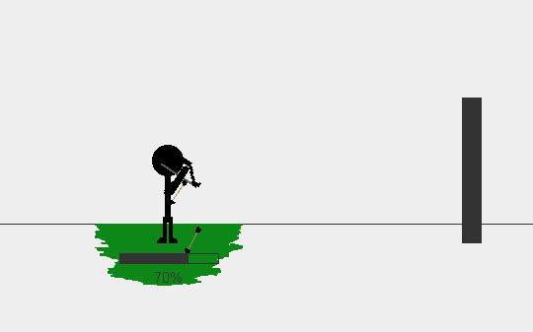

Slay your enemy!

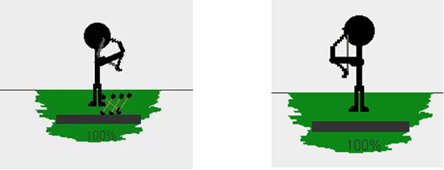

VICTORY!

